Pinterest

🎓 Definition
# Source: ScreenShots Source: Provided by: [Persons Table -> ID Column: 1, Name_En Column: Motasem Essam] -> Tool: [Lightshot Program] -> From [Site: https://www.pinterest.com/] on [11/14/2025]
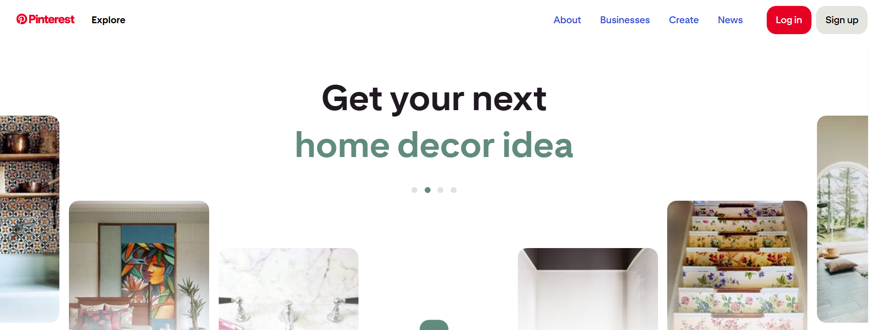
# Source: AI Source: Provided by: [Data Path: Persons Table -> ID Column: 1, Name_En Column: Motasem Essam] -> From: [ChatGPT] on [11/14/2025]
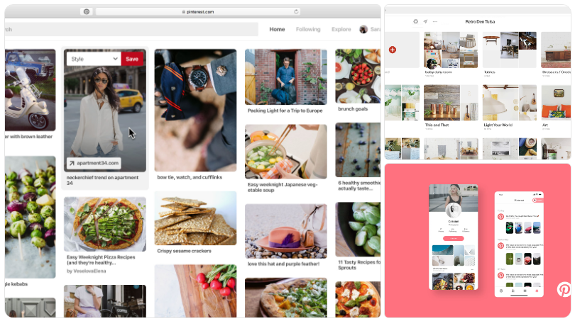
Pinterest is a visual discovery and bookmarking platform where users find, save, and share ideas using images and videos. (Pinterest Help)
- It was founded in 2009 by Ben Silbermann, Paul Sciarra and Evan Sharp, and launched publicly in March 2010. (Wikipedia)
- The name is a blend of “pin” + “interest” — reflecting the idea of “pinning” what interests you. (Wikipedia)

📊 How it works
# Source: AI Source: Provided by: [Data Path: Persons Table -> ID Column: 1, Name_En Column: Motasem Essam] -> From: [ChatGPT] on [11/14/2025]
- Users browse through a “home feed” of pins (images or videos) based on their interests, people they follow, and topics. (Pinterest Help)
- A Pin can be:
  - An image or video uploaded by a user
  - Or an “image link” saved from somewhere else on the web
- Users organize Pins into Boards (themes or projects) — e.g., “Home décor”, “Travel ideas”, “Recipes”. (TechTarget)
- Users can follow other users, boards, and topics to see more of what interests them. They can also “repin” pins from others to their own boards. (Wikipedia)
- Pinterest has search features (text + recently visual search) that let users find ideas even when they don’t know the words for them. (TechTarget)

🎯 What it’s used for
# Source: AI Source: Provided by: [Data Path: Persons Table -> ID Column: 1, Name_En Column: Motasem Essam] -> From: [ChatGPT] on [11/14/2025]
- Discovering ideas and inspiration — from craft projects to home renovation, fashion, food, weddings, travel, etc. (Pinterest Help)
- Planning or organizing projects: e.g., looking for recipes, mood boards, design ideas, DIY tutorials.
- Sharing your interests or aesthetic: by creating boards and uploading content.
- For businesses/marketers: Using Pinterest to drive traffic, showcase products, reach audiences via visual content. (TechTarget)

✅ Legality, Safety & Things to Consider
# Source: AI Source: Provided by: [Data Path: Persons Table -> ID Column: 1, Name_En Column: Motasem Essam] -> From: [ChatGPT] on [11/14/2025]
- The platform is legal and widely used. However:
  - Because it is largely user-generated content, there are copyright considerations: some images shared may be reposted without proper attribution or permission. (Wikipedia)
  - As with any social platform, user-privacy, content moderation, and safety (especially for younger users) are relevant topics.
  - Some regions/countries have blocked or restricted Pinterest at times. (Architectural Digest)

📝 Summary
# Source: AI Source: Provided by: [Data Path: Persons Table -> ID Column: 1, Name_En Column: Motasem Essam] -> From: [ChatGPT] on [11/14/2025]
Pinterest is essentially a visual discovery engine + social bookmarking platform, helping users collect, organize, and explore ideas using Pins and Boards. It combines aspects of social media, search, and inspiration sourcing in a visually-rich interface.

